

Immokalee, Florida

**Fairfield Prep’s**

**Christian Service Trip Handbook**



**Table of Contents**

1. About Fairfield Prep’s Service Trips **3**
2. About Immokalee **5**
3. Projects **6**
4. Costs  **7**
5. Financial Assistance  **7**
6. Health and Safety  **8**
7. What to Bring **9**
8. Frequently Asked Questions  **9**
9. Policies and Rules **12**
10. Agreement Form **13**
11. **About Fairfield Prep’s Service Trips**

Juniors and Seniors, and sometimes Sophomores, at Fairfield Prep are provided with the opportunity to attend Service Immersion trips to several different communities. Students who choose to participate do so by dedicating part of their weekend or school vacation for the opportunity to serve, live, and build relationships with communities throughout the United States, the Americas or Jamaica.

The profile of the Graduate at Graduation, which is the goal for all Jesuit educated students, requires the graduate to be open to growth, intellectually competent, religious, loving, and committed to doing justice. The Service Immersion opportunities offered by Fairfield Prep undoubtedly aid the process of developing young men who exhibit all of these qualities. In addition to deepening their relationship with themselves and Christ on these trips, the students also make new, and strengthen already existing, relationships with their classmates.

The mission of Service Immersion trips is to provide students with transformational short-term service immersion opportunities that incorporate community, spiritual reflection, simplicity, and increased awareness of social injustice. Integrated throughout the immersion experience is the Daily Examen. The Daily Examen is a technique of prayerful reflection on the events of the day in order to detect God’s presence and discern his direction for us. This method of reflection comes from St. Ignatius of Loyola’s *Spiritual Exercises*. It is in these experiences that we hope to inspire growth and change in a way that resonates back home through the sharing of stories and action toward systemic change.

Fairfield Prep does not bring students to communities throughout the country, Americas and Jamaica to build houses, but to build bridges between these communities and our own.

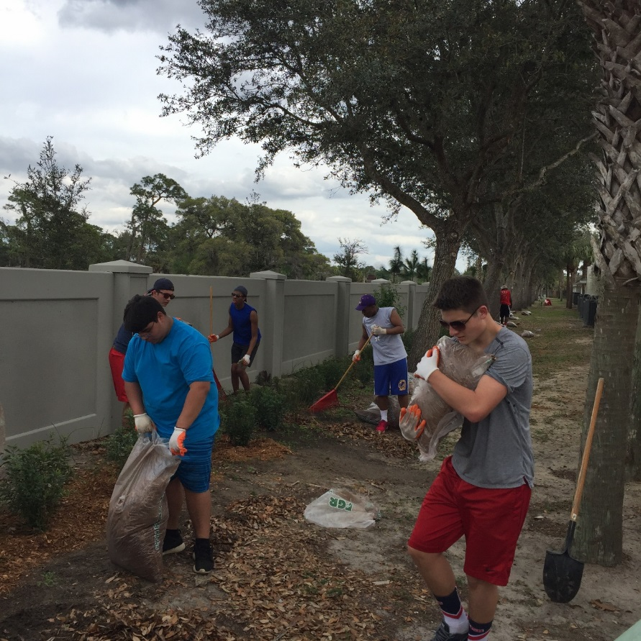

1. **About Immokalee**

Immokalee, FL is a small town with a diverse population. Many people originally from Mexico, Haiti, & Guatemala have come to this area to work in the agricultural fields and provide a better future for their children. This is also home to a group of Seminole Indians. The people of Immokalee are by and large very hard working, kind, and faith-filled.

On this week-long immersion your students will be introduced to the unique town of Immokalee and its residents, sharing in service, labor, play, discussion, meals, learning, and fun.  During the day, students will take turns visiting different service locations and spend time working in an after-school program. In the evenings guest speakers will present on topics such as immigration, health issues facing the community, the evolution of farmworker rights, and the particular issues facing youth (particularly teens such as themselves) in this community.

1. **Projects**

*(Please note that the following listed are subject to change depending on availability and scheduling via the Humility of Mary Volunteers.)*

Potential service activities include:

·       Home construction with Habitat for Humanity

·       Homework help with an Elementary After-School Program

·       Classroom assistance at a VPK “Head Start” learning facility

·       Soccer & Study sessions with Immokalee Soccer School & Academy

·       General volunteering with Catholic Charities Social Services

(donation sorting & soup kitchen)

Evening Presentation topics include:

·       Immigration

·      The Immokalee Soccer School & Academy

·       Health in Immokalee

·       A field worker’s experience/an “undocumented person’s”

experience

·       A public school teacher’s perspective

·       Presentation by world-renowned Coalition of Immokalee Workers

1. **Costs**

Students who apply for this trip through Fairfield Prep’s Christian Service Department and are accepted will be asked to pay for their trip in two payments of $500, totaling $1,000 for the trip.

This cost includes transportation to and from the airport, the flight, all meals while in Immokalee, ground transportation in Florida and lodging.

This cost DOES NOT include meals in the airports, cost of any souvenirs purchased by the student.

1. **Financial Assistance**

Students who apply for acceptance on this trip can also apply for financial assistance to help pay the costs due to Fairfield Prep. Students who qualify for financial assistance towards their tuition at Fairfield Prep will also qualify for financial assistance towards the trip. However, the amount of financial assistance granted for the trip will depend on the number of accepted students who have applied and qualify. The maximum grant given is generally 50%. Those who do not qualify for tuition assistance will NOT qualify for trip assistance. It is also important to note that whether or not a student applies for financial assistance has no bearing on the decision to accept or deny a student’s application for this trip.

1. **Health and Safety**

When traveling in unfamiliar areas, groups can become victims of crime and violence, or experience unexpected difficulties. By adhering to the following health and safety tips Fairfield Prep will try to create as safe an environment as possible when traveling throughout the city of Bridgeport.

**Always Keep in Mind**

* Participants should never go anywhere alone and always let an adult chaperone know where they will be and obtain permission. The responsibility to adhere by this rule falls on the participant as it is not feasible for the adult chaperones to monitor doors and windows twenty-four hours a day.
* Participants should never carry large amounts of money or expensive devices. If a participant chooses not to adhere by these rules and his items are dirtied, stolen or misplaced the responsibility will lie on the participant.

1. **What to Bring**

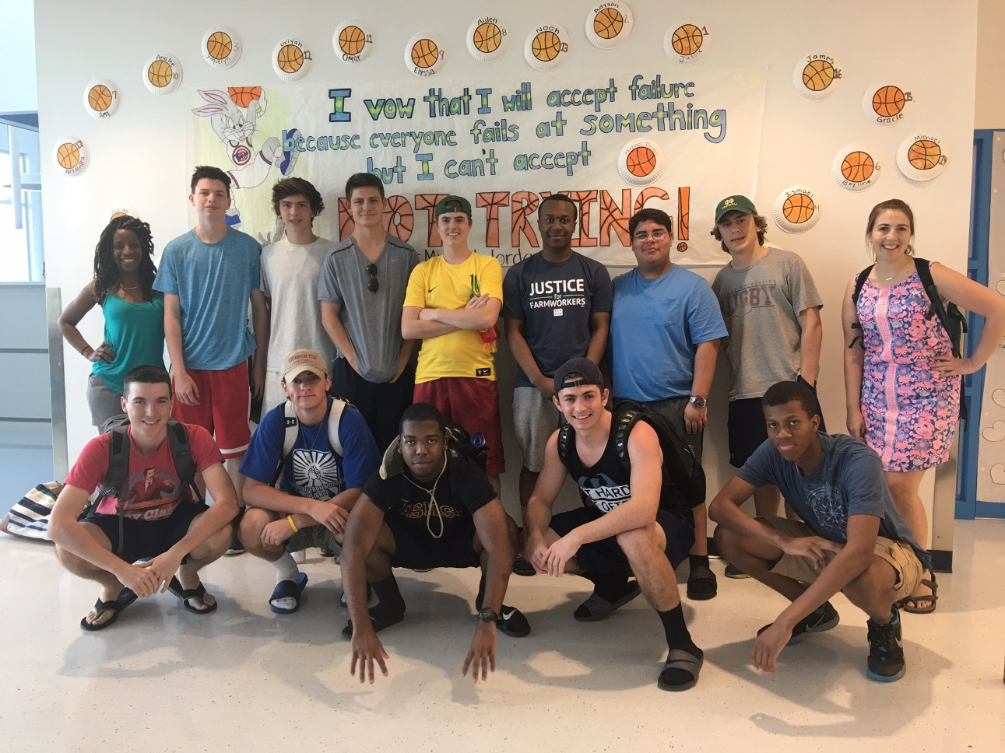**TBD.**Information will be shared with participants as trip details develop.

1. **Frequently Asked Questions**

*What will be the group’s accommodations?*

The group will be staying at Bethel Retreat House, just outside of Immokalee for the duration of their trip.

*Will there be access to the internet or cell phones?*

No, the participants will not have access to the internet or a phone. Once the group arrives in Florida, the Fairfield Prep adult chaperones will contact home to make sure each participant’s family is contacted via email. After this email, participants will only have access to the internet phone calls in the case of an emergency. Contact information for the Humility of Mary Volunteers and the Fairfield Prep chaperones will be provided in case a participant needs to be reached in the case of an emergency while traveling.

*Can participants bring an iPad, iPod or other electronics?*

Participants can bring an iPod or iPhone to listen to music on the plane, but once the group arrives in Immokalee, these devices should be turned in for safe keeping. If the participant chooses not to hand over their device and it is seen out throughout the trip, the adult chaperone will confiscate it and return it to the participant when arrive back from the trip. If the device is dirtied, stolen or destroyed at any time only the participant will be responsible.

*Is this trip safe?*

The trip is as safe as any other trip offered by Fairfield Prep. Although there are no guarantees of safety, there are some simple precautions to take.

Fairfield Prep students can be seen as wealthy (even if they do not regard themselves as such) and a target for robbery. The group will be less likely to be a target of crime if they abide by the guidelines set under “Always Keep in Mind” on page 9 of this document.

*What happens if a participant becomes ill or injured?*

Participants can receive basic medical attention from the Fairfield Prep chaperones on the trip with parent or guardian permission. Should it happen that a participant becomes seriously ill to the point where it is affecting the retreat experience, it is the decision of the chaperones, the participant’s family, and the participant whether to remain on the retreat or return to home. If the participant does choose to return, a parent or guardian must pick them up at the Urban Center. In all situations where medical attention is needed the participant’s emergency contact will be contacted and made aware.

In the event that emergency medical attention is needed, 911 will be called and the student’s emergency contact person will be contacted immediately.

1. **Policies & Rules**

Just as with any Prep sponsored event, all policies and rules listed in the Fairfield Prep Student Handbook are in effect not only during the immersion experience, but also during meetings before and after the trip as well as during all travel to and from the immersion location. In addition, students must also follow all rules and regulations stipulated by the organizations and agencies our immersion program partners with. Failure to adhere to those policies may result in a student not receiving service hours toward their Theology requirement and further disciplinary action. Depending on the severity of the transgression, students may have to report to the Director of Discipline and it is possible that they may be asked to leave the trip at their own expense. If there are any questions regarding what behavior is or is not acceptable, please consult the Student Handbook. If further explanation is needed, please see the Director of Christian Service for clarification.

**Fairfield Prep’s Christian Service Handbook Agreement Form**

In signing this document, I certify that I have read and understood

Fairfield Prep’s Christian Service Trip Handbook. The content in these documents was reviewed with me during an evening information session, or a make-up meeting, and I had a chance, if necessary, to ask questions for clarification.

___________________________

**Participant Name (print)**

___________________________

**Participant Signature**

___________________________

**Signature of a parent or legal guardian**

___________________________

**Date**

___________________________

**Date**