

Rostro de Cristo

Ecuador

**Fairfield Prep’s**

**Christian Service Trip Handbook**

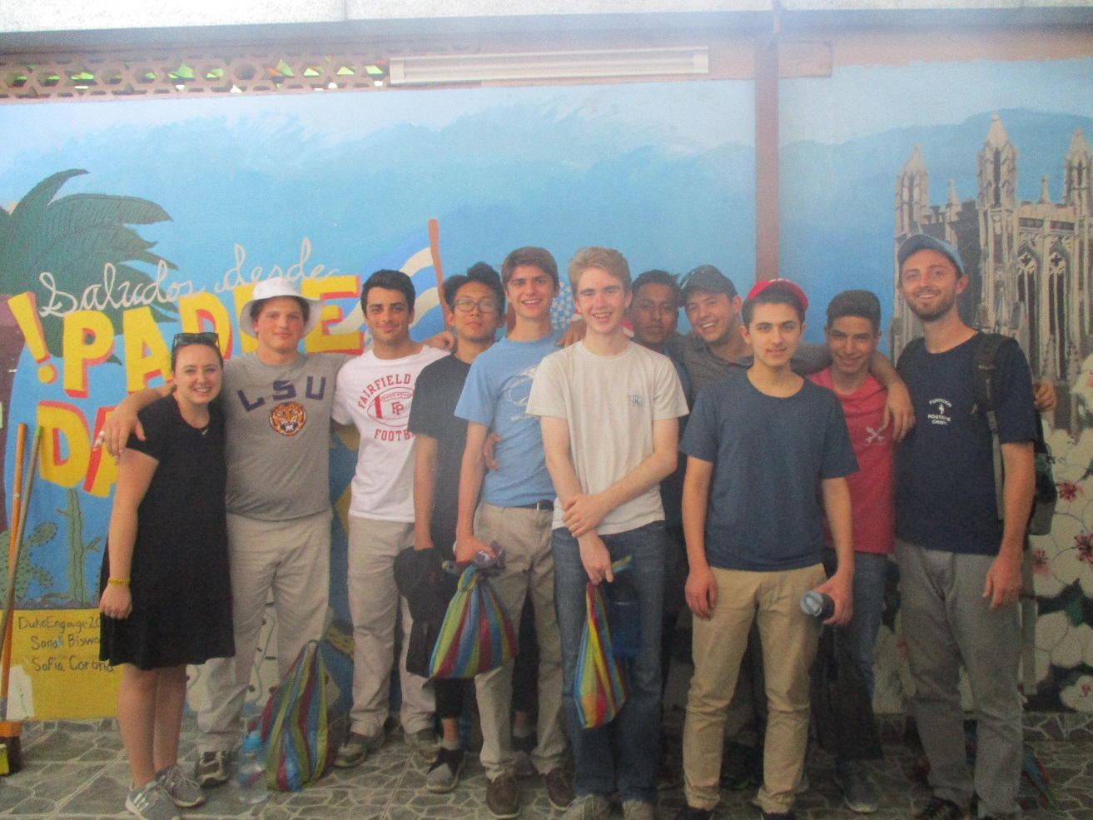

**Table of Contents**

1. About Fairfield Prep’s Service Trips **3**
2. About Rostro de Cristo **5**
3. Projects **6**
4. Sample Itinerary **15**
5. Costs **18**
6. Financial Assistance **18**
7. Health and Safety **19**
8. What to Bring **26**
9. Frequently Asked Questions **27**
10. Policies and Rules **31**
11. Agreement Form **32**
12. **About Fairfield Prep’s Service Trips**

Juniors and Seniors, and sometimes Sophomores, at Fairfield Prep are provided with the opportunity to attend Service Immersion trips to several different communities. Students who choose to participate do so by dedicating part of their weekend or school vacation for the opportunity to serve, live, and build relationships with communities throughout the United States, the Americas or Jamaica.

The profile of the Graduate at Graduation, which is the goal for all Jesuit educated students, requires the graduate to be open to growth, intellectually competent, religious, loving, and committed to doing justice. The Service Immersion opportunities offered by Fairfield Prep undoubtedly aid the process of developing young men who exhibit all of these qualities. In addition to deepening their relationship with themselves and Christ on these trips, the students also make new, and strengthen already existing, relationships with their classmates.

The mission of Service Immersion trips is to provide students with transformational short-term service immersion opportunities that incorporate community, spiritual reflection, simplicity, and increased awareness of social injustice. Integrated throughout the immersion experience is the Daily Examen. The Daily Examen is a technique of prayerful reflection on the events of the day in order to detect God’s presence and discern his direction for us. This method of reflection comes from St. Ignatius of Loyola’s *Spiritual Exercises*. It is in these experiences that we hope to inspire growth and change in a way that resonates back home through the sharing of stories and action toward systemic change.

Fairfield Prep does not bring students to communities throughout the country, Americas and Jamaica to build houses, but to build bridges between these communities and our own.

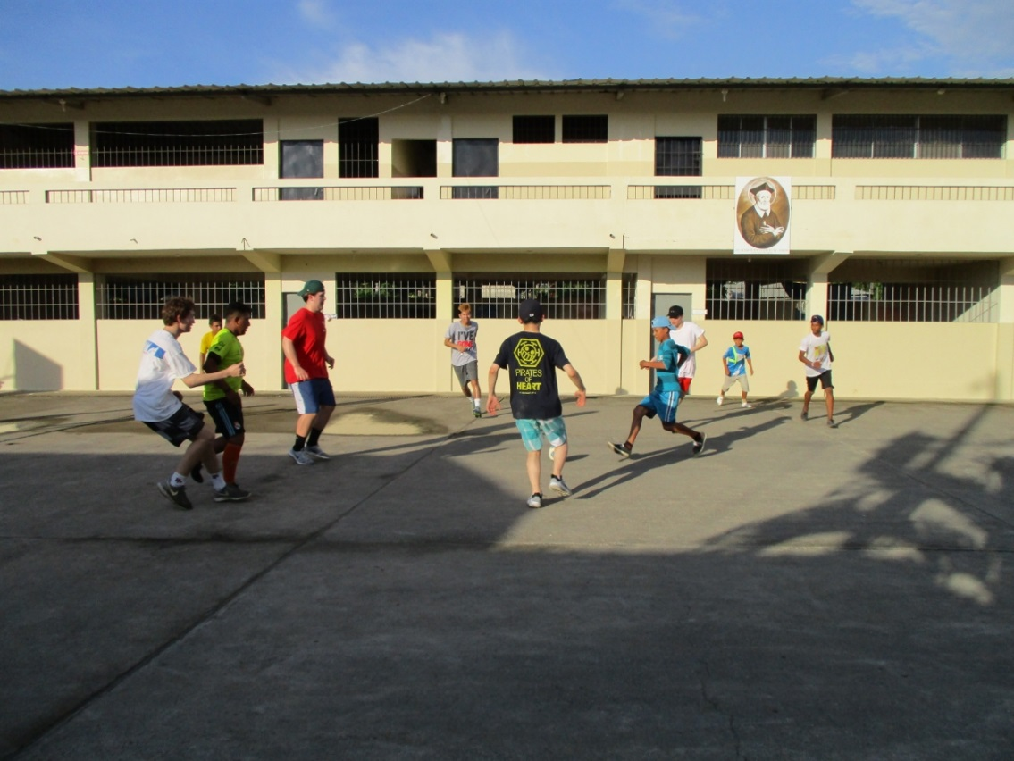

1. **About Rostro de Cristo**

Founded in 1988 by Fr. Jim Ronan of the Archdiocese of Boston, MA, Rostro de Cristo (Face of Christ) is a Lay Volunteer Program of the Catholic Church based in Guayaquil, Ecuador.

The main purpose of the program is to challenge young people to follow the example of Jesus by living and working among the poor, and by recognizing the face of Christ in them.

The lay volunteers and retreat participants are young people from the U.S. who have been called by God to Ecuador to deepen their faith in two main ways: by living and praying in community and by serving others less fortunate than themselves.

Rostro de Cristo fulfills its spiritual and educational mission in two ways: by offering volunteer and retreat experiences to young adults from the United States, while also supporting various education, health and other social service projects in Ecuador.

Rostro de Cristo is a Catholic program whose mission is to provide spiritual and educational opportunities for people of faith to live out the Gospel of Jesus Christ together with the people of Ecuador. The program invites participants from the United States to:

* Be in relationship with the Ecuadorian people and reflect on the face of Christ in their joys and struggles.
* Support Ecuadorian people in their work to achieve a justice rooted in Gospel values in their developing communities.
* Lead a simple lifestyle and build an intentional Christian community.

1. **Projects**

The volunteer opportunities that Fairfield Prep students participate in while in Ecuador vary from year to year. However, Fairfield Prep’s groups travel to Ecuador to help Rostro de Cristo in as many ways as possible and therefore travel under the assumption that they will assist the Ecuadorian people in all of the following communities and projects:

*(Communities are listed below by number and the projects are listed by lower case letter under the community where these projects will occur)*

* + - 1. **Arbolito**

Construction of the Arbolito Community house began in 2002 and was completed in August of 2003. As of 2005, Arbolito became the home of Rostro de Cristo’s second retreat house, which serves 12 groups a year. Arbolito itself started as an invasion, meaning people built their houses on unclaimed land. From all across Ecuador, different people have come to Arbolito hoping to find work in Durán and Guayaquil.

**Semillas de Mostaza**

Semillas de Mostaza is a Rostro de Cristo supported program that functions as an after-school program for the children in and around Arbolito in Duran, Ecuador. There are over 150 children that are in the program with about an average of forty five children attending daily. The program formally started in 2001 with a small group of students in the back of the local church. In 2002 “Semillas” moved to its current location, The John Drury Wilson Technical School. Currently, the program is a group effort of both Rostro de Cristo & former Semillas students. At Semillas de Mostaza, Fairfield Prep students will serve the community in the following ways:

* + Give the children their snacks and vitamins
  + Play soccer, basketball, “Tag” and other athletic games with the children
  + Play board games or playing cards with the children
  + Read to the children
  + Help the children with their educational worksheets
  + Help the Semillas de Mostaza employees monitor the students’ behavior

1. **Mt. Sinai**

Starting in September 2009, Rostro has had a presence in Monte Sinai (Mount Sinai). Located on the Perimetral in northwest Guayaquil, about an hour by car from Duran, this neighborhood is currently home to six Rostro de Cristo volunteers. People began moving to Monte Sinai about nine years ago. To entice people to buy land in Monte Sinai, plots were sold very inexpensively. When the first people moved into Mount Sinai, neither buses nor water trucks entered the neighborhood. There were no stores and no basic services. Neighbors had to walk a mile or so to a main paved road to wait for water trucks so that their families could receive water or to catch a bus to buy food or go to school. Now, after much time and struggle, the neighborhood is growing and changing.

* 1. **Escuela San Felipe Neri**

The San Felipe Neri School opened in April of 2009 and is located just a few blocks away from the Rostro de Cristo house. The school is run by the Hermanas Filipenses, a dynamic group of Colombian nuns. They have been adding a grade each year and currently teach K-3 grades. Because of lack of funding to pay for an additional teacher, the second and third graders are in one combined classroom. At the Escuela San Felipe Neri, Fairfield Prep students will serve the community in the following ways:

* + Give the children their snacks and vitamins
  + Play basketball, soccer, “Tag” and other athletic games with the children
  + Play board games or playing cards with the children
  + Read to the children
  + Help the children with their educational worksheets
  + Help the staff monitor the students’ behavior
  + Teach computers and English to all grade levels
  1. **Santiago Apóstol**

Directed by the Christian Life Movement, this foundation provides classes, recreation time, spiritual formation, and meals to around sixty children who used to be working on the streets. The majority of the students are between the ages of 11 and 16, and are in this school to complete their primary education and move on to high school. Their families are also given classes on the weekends in hopes that they are able to get the children and their parents off the street by working with micro-empresas (small businesses), which would allow the children to go to school. At Santiago Apóstol, Fairfield Prep students will serve the community in the following ways:

* + Give the children their snacks and vitamins
  + Play basketball, soccer, “Tag” and other athletic games with the children
  + Play board games or playing cards with the children
  + Read to the children
  + Help the children with their educational worksheets
  + Help the staff monitor the students’ behavior
  + Teach computers and English to all grade levels

1. **Padre Damien House**

Damien House is a foundation that works to bring “dignity to the lives of those affected by Hansen’s Disease.” This disease, also known as leprosy, is chronic and infectious and is caused by tiny bacteria that invade the body. Symptoms and signs include nerve damage, skin lesions, weakened muscles and bone deterioration. Because of the ignorance that still exists regarding the disease, Damien House works to educate its patients and the public about treatment. There is a cure for Hansen´s Disease, a multi-drug therapy that takes up to 3 years to cure.

The Foundation spreads awareness about the disease and acts as an agency to distribute the medication. The fifty in-house patients are cared for by a loving and committed staff and by volunteers. The retreat groups visit the patients and support them financially by buying their crafts. At Padre Damien House, Fairfield Prep students will serve the community in the following ways:

* + Sit and interact with the patients
  + Play Dominos, chess and other board games with the patients
  + Sing songs with the patients
  + Crochet with the patients as a form of hand therapy

1. **Proyecto Salesiano Chicos de la Calle**

The Proyecto Salesiano Chicos de la Calle is a Catholic foundation run by the Salesian congregation. The program consists of 3 shelters, a street outreach program, two after school programs, and a recreation and catechism program on weekends. Rostro de Cristo volunteers work in the third shelter, Albergue Nuestros Hijos, located in Duran. At Proyecto Salesiano Chicos de la Calle, Fairfield Prep students will serve the community in the following ways:

* + Learn about the shelter
  + Play basketball, soccer, “Tag” and other athletic games with the Ecuadorians
  + Tutor the children

1. **Veintiocho de Agosto**

Founded on August 28, 1997, this growing community is based around what used to be an active trash dump. Eleven full trucks each made two trips a day, seven days a week, providing a recycling industry for members of the community brave enough to search for plastics and glass products underneath and within heaps of household waste. Herds of cattle and pigs would feed on the trash and, unsurprisingly, various health problems accompany the ever-present insects. To keep their neighborhood from literally turning into a mountain of trash, the people burned all that is non-recyclable; there are horrendous consequences for general respiratory health. For these and other reasons, many children living in Veintiocho de Agosto are, on average, three years behind developmentally in terms of normal height and weight for healthy Ecuadorian children.

* 1. **Manos Abiertas**

Manos Abiertas, or Open Hands, is an after school program for children and adolescents ages 3 and up in the community of Veintiocho de Agosto. Up until the spring of 2004, this community was the local dump site for all of Durán. Many children of this community live in overcrowded one room cane houses, and have no space or resources to complete basic homework assignments, or to safely play. Manos Abiertas began in the spring of 2005 to offer these children a safe space to do homework, learn, play, and be kids. At Manos Abiertas, Fairfield Prep students will serve the community in the following ways:

* + Give the children their snacks and vitamins
  + Play soccer, basketball, “Tag” and other athletic games with the children
  + Play board games or playing cards with the children
  + Read to the children
  + Help the children with their educational worksheets
  + Help the Semillas de Mostaza employees monitor the students’ behavior

1. **Other Possibilities**

As previously stated, Fairfield Prep’s groups travel to Ecuador with the Ecuadorian people’s needs in mind before their own. Therefore, if the group is asked to complete manual labor jobs they will do as asked. These jobs will include:

* + Painting
  + Weeding
  + Using hammers and nails

1. **Itinerary**

The below itinerary is from Fairfield Prep’s 2016 trip to Ecuador. The group was placed in Rostro de Cristo’s Mt. Sinai retreat house. The retreat house where Fairfield Prep’s group is placed and the order of events on this itinerary will change from year to year, but each location that will be visited by the group is listed under “Projects” on page 6 of this document.

**Day 1, Friday, April 8, 2016 – Travel Day**

The group arrived at Fairfield Prep at 7:15 AM and took a bus from First Student Bus Company to LaGuardia Airport. The group arrived in Guayaquil at 2:40 PM, 3:40 PM eastern standard time, and was greeted by a group of year-long Rostro de Cristo Volunteers. The Fairfield Prep group met the volunteer assigned to their group for the week and took the Rostro de Cristo van to their retreat house in Mt. Sinai. They had a brief orientation in the neighborhood, had dinner, a brief reflection and retired for the night.

**Day 2, Saturday, April 9, 2016 – Work Day**

This day was spent at the Damien House with the Hansen’s Disease patients. The group also had the opportunity to meet their neighbors for the week and begin to build relationships with the community. This day ended, as all days did, with a group reflection in the evening before bed.

**Day 3, Sunday, April 10, 2016 – Church Day**

On Day 3, the group experienced a Catholic Mass in Ecuador. The majority of the day was occupied by resting and building relationships with each other and the Ecuador communities. They played soccer with the neighborhood children and prepared their meals for the day.

**Day 4 to 6, Mon., April 11, 2016 – Wed., April 13, 2016 – Projects**

These days were spent at the Damien House, visiting Nuevo Mundo and volunteering in after school programs in the local community. The after school programs, that were each visited twice, were Escuela San Felipe Neri and Santiago Apóstol. The group, with the help of a Rostro de Cristo employee, prepared their own dinners each night.

**Day 7, Thursday, April 14, 2016 – Fun/Packing Day**

On the last full day for the group they visited the city of Guayaquil in the morning. They had the opportunity to buy souvenirs and experience the beauty that Ecuador has to offer. The afternoon was spent cleaning the house and packing as their flight left on this night at 11:55 PM.

**Day 8, Friday, April 15, 2016 – Travel Day**

The group spent all of this morning on a plane back to the United States. The group had a layover in Miami before arriving at LaGuardia Airport at 10:20 AM. The group was picked up by a school bus from First Student Bus Company at the airport and brought back to Fairfield Prep where their parents awaited their arrival.

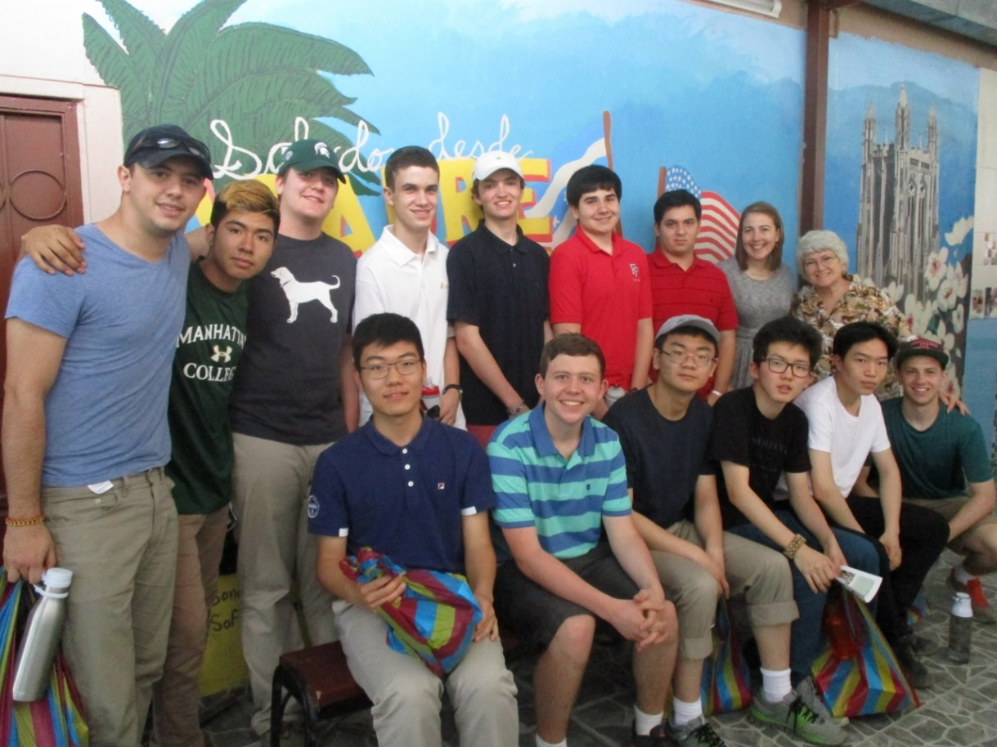

1. **Costs**

Students who apply for this trip through Fairfield Prep’s Christian Service Department and are accepted will be asked to pay for their trip in two equal installments. This trip generally costs between $1,800 and $2,200.

This cost includes transportation to and from the airport, the flight, all meals while in Ecuador, purified water, short term travel insurance, entry fee into Ecuador, lodging.

This cost DOES NOT include medical and immunization fees leading up to the trip, passport fees, meals in the airports, cost of any souvenirs purchased by the student.

1. **Financial Assistance**

Students who apply for acceptance to this trip can also apply for financial assistance to help pay the costs due to Fairfield Prep. Students who qualify for financial assistance towards their tuition at Fairfield Prep will also qualify for financial assistance towards the trip. However, the amount of financial assistance granted for the trip will depend on the number of accepted students who have applied and qualify. The maximum grant given is generally 50%. Those who do not qualify for tuition assistance will NOT qualify for trip assistance. It is also important to note that whether or not a student applies for financial assistance has no bearing on the decision to accept or deny a student’s application for this trip.

1. **Health and Safety**

When traveling abroad, whether it is a developing country or not, travelers can become victims of crime and violence, or experience unexpected difficulties. By adhering to the following health and safety tips Fairfield Prep will try to create as safe an environment as possible when traveling to Ecuador.

**Medical Insurance**

Parents should consult with their family’s medical insurance provider to discuss the extent of their son’s medical coverage while traveling in Ecuador. Fairfield Prep purchases a secondary basic, short-term travel medical insurance plan for each student. This cost is covered in the student’s payment for the trip. Information containing the detailed coverage policies will be given to the family of each traveler upon the purchase of the plan. Parents will be responsible for any medical expenses not covered by their primary insurer.

**Clean Hands and Clean Water**

It is important that each student regularly washes their hands and drinks ONLY purified water. When brushing their teeth students should also use purified water. Purified water will be supplied by Rostro de Cristo and will be available 24/7 for all members of the group.

All water used to wash/cook the group’s food must be boiled first. A Rostro de Cristo year-long volunteer and a Rostro de Cristo employee will monitor all washing and cooking in the kitchen.

Students will consistently be reminded to use purified water for drinking and brushing their teeth. They will also be reminded not to swallow any of the water in the shower. However, a Rostro de Cristo employee and/or a Fairfield Prep faculty chaperone cannot, and will not, be with the student each time they brush their teeth and therefore the responsibility lies in the hand of the student to adhere by these guidelines.

**Visit Your Doctor**

At least 4-6 weeks prior to the trip all participants must meet with their primary care physician, a doctor from Bridgeport Hospital’s Safe Travel Department or another safe travel department in the area in order to be cleared to travel and receive the doctor’s recommended immunizations. Based on the recommendations of Rostro de Cristo, Fairfield Prep will require all participants to have at the very least an updated Tetanus vaccination (up to 5 years), Typhoid vaccination (up to two years), and Hepatitis A and B. Some doctors may also recommend Malaria Pills, traveler’s diarrhea medication and/or a Yellow Fever vaccination. The decision to take Malaria Pills, traveler’s diarrhea medication and/or receive a Yellow Fever vaccination will be up to the participant’s doctor, the participant and his family.

All participants who take prescription medication are required to make the Fairfield Prep chaperones aware that they will be taking medication while traveling. All participants are also required to inform Fairfield Prep’s Director of Christian Service of any existing medical concerns at least four weeks before departure for Ecuador. For example, the Director of Christian Service must know if a student has allergies, asthma, etc. All participants will be responsible for their own medications while on this trip unless an arrangement is made between the participant’s guardian and the Director of Christian Service.

**Always Keep in Mind**

* Participants should never go anywhere alone and always let an adult chaperone know where they will be. No participant is permitted to leave Rostro de Cristo’s compound without the supervision of a Rostro de Cristo volunteer or employee. The responsibility to adhere by this rule falls on the participant as it is not feasible for the adult chaperones to monitor doors and windows twenty-four hours a day.
* Participants should never carry their passports or large amounts of money. All expensive items should be turned into the Rostro de Cristo year-long volunteer upon their arrival to the compound to be put into a safe for the duration of the trip. If a participant chooses not to submit valuables for safe keeping and these items are stolen or misplaced the responsibility will lie on the participant.
* No participant should wear clothing with logos (i.e. Nike, Adidas, etc.), jewelry, or fancy accessories while in Ecuador.

**Security**

Rostro de Cristo employs armed security guards to be with the group 24 hours a day during their visit. Security guards will meet the group at the airport in Guayaquil and escort them to the compound. Each time the group travels via car the security guards will escort them. The compound will be guarded by armed security at all times. The presence of security makes the group less likely to be victims of a crime, but safety cannot be guaranteed.

**Other Risks and Prevention Methods**

The below risks and prevention methods are provided by the Centers for Disease Control and Prevention’s website, wwwnc.cdc.gov., which must be visited by all participants prior to the trip for an updated list:

**Bugs**

Bugs (like mosquitoes, ticks, and fleas) can spread a number of diseases in Ecuador. Many of these diseases cannot be prevented with a vaccine or medicine. Risk can be reduced by taking steps to prevent bug bites.

**What can be done to prevent bug bites?**

* 1. Cover exposed skin by wearing long-sleeved shirts, long pants, and hats.
  2. Use an appropriate insect repellent (see page 18).
  3. Use permethrin-treated clothing and gear (such as boots, pants, socks, and tents). Do **not** use permethrin directly on skin.
  4. Use a bed net if the area where you are sleeping is exposed to the outdoors.

**What type of insect repellent should be used?**

* 1. **FOR PROTECTION AGAINST TICKS AND MOSQUITOES:** Use a repellent that contains 20% or more **DEET** for protection that lasts up to several hours.
  2. Always use insect repellent as directed.

**What should be done if someone is bitten by bugs?**

* 1. Avoid scratching bug bites, and apply hydrocortisone cream or calamine lotion to reduce the itching.
  2. Check their entire body for ticks after outdoor activity. Be sure to remove ticks properly.

**Animals**

Most animals avoid people, but they may attack if they feel threatened, are protecting their young or territory, or if they are injured or ill. Animal bites and scratches can lead to serious diseases such as rabies.

Each participant should follow these tips to protect themself:

* Do not touch or feed *any* animals you do not know.
* Do not allow animals to lick open wounds, and do not get animal saliva in your eyes or mouth.
* Avoid rodents and their urine and feces.
* If you wake in a room with a bat, seek medical care immediately. Bat bites may be hard to see.

All animals can pose a threat, but be extra careful around dogs, bats, monkeys, sea animals such as jellyfish, and snakes. If you are bitten or scratched by an animal, immediately:

* **Wash** the wound with soap and clean water.
* **Go** to a doctor right away.
* **Tell** your doctor about your injury when you get back to the United States.

**Note:** As with the issue of using only clean water, Fairfield Prep chaperones will remind students of the above listed prevention methods, but cannot monitor each participant twenty-four hours a day. Therefore, it is the responsibility of each participant to know and follow these prevention methods.

1. **What to Bring**

* Pillow
* Sheets (including fitted)
* Flashlight
* Work Gloves
* Long pants: 1 pair, light weight, no denim (for church)
* 1 Collared Shirt (for church)
* Work Clothes (clothes that you would not mind ruining), 1 per day
* Sneakers (sneakers that you would not mind ruining)
* Sandals (for use in the house)
* Towel(s); No more than 2 will be necessary
* Toiletries (shampoo, soap, hand sanitizer)
* 1 Package of Kleenex (travel size)
* Sun Tan Lotion (Minimum SPF 30)
* Baseball Hat
* Sunglasses
* Personal medications/other needs (For example, if you wear contacts bring a pair of glasses just in case. **Do** bring Advil or something similar that you prefer. **Do not** bring Pepto Bismol or first aid items. The group will have such items at their disposal as/if needed.
* Money for food during travel. No more than $100 will be necessary.

**What NOT to Pack:**

* Too much of anything
* Jewelry of any kind
* Cameras or other electronic devices (iPods, cell phones, laptops, etc. should be left at home) One digital camera will be provided by the school.

1. **Frequently Asked Questions**

*What will be the group’s accommodations?*

The group will be staying in one of Rostro de Cristo’s compounds about 45 minutes from the airport. The participants will be sharing bedrooms with bunk beds. Each participant will have their own bed and access to a mosquito net if they wish to use one while sleeping. They will share a bathroom with limited access to a shower. There is electricity in the compound.

*Will there be access to the internet or international calls?*

No, the participants will not have access to the internet or a phone. Once the group arrives to the compound the Fairfield Prep adult chaperones will contact home to make sure each participant’s family is contacted via email. After this email, participants will only have access to the internet or international calls in the case of an emergency. Contact information for Rostro de Cristo and the Fairfield Prep chaperones will be provided in case a participant needs to be reached in the case of an emergency while traveling.

*Can participants bring an iPad, iPod or other electronics?*

Participants can bring an iPod or iPhone to listen to music on the plane, but once the group arrives to the compound in Ecuador these devices should be turned in to be placed in the group’s safe. If the participant chooses not to hand over their device and it is seen out throughout the trip, the adult chaperone will confiscate it and return it to the participant when they land in the United States. If the device is dirtied, stolen or destroyed at any time only the participant will be responsible.

*Is this trip safe?*

The trip is as safe as any other trip overseas. Although there are no guarantees of safety anywhere in the world, including the U.S., there are some simple precautions to take. The U.S. State Department issues consular information sheets and travel warnings, summarizing entry requirements and health and safety issues, for all foreign countries. Read them at the State Department website, travel.state.gov, and check the website for up-to-date information. Each participant’s own responsible and intelligent behavior is required for their safety.

North Americans can be seen as wealthy (even if they do not regard themselves as such) and a target for robbery, and as representatives of U.S. foreign policy and a target for political retaliation (even if they oppose that policy). The group will be less likely to be a target of crime if they abide by the guidelines set under “Always Keep in Mind” on page 22 of this document.

In many parts of the world road travel is much less safe than in the U.S., because of road conditions, the general quality of driving and observation of road laws, or vehicle safety standards. Seat belts will be required for everyone riding in the vans throughout the trip. Also, only licensed and trained Rostro de Cristo employees and volunteers will be driving the vans.

*Is it necessary to speak Spanish to participate?*

No, it is not necessary. The year-long Rostro de Cristo volunteer is always bilingual and serves as a translator for the group. It is also not uncommon for there to be one or two bilingual participants in the group.

*What happens if a participant becomes ill or injured?*

The Rostro de Cristo houses are located within five minutes of local health clinics run by one of their partner foundations; retreat participants can receive basic medical attention here from doctors who are used to treating the Rostro de Cristo volunteers. In the event that emergency medical attention is needed, there is a hospital in Guayaquil. The participant only needs to ask for medical care and arrangements will be made. Should it happen that a participant becomes seriously ill to the point where it is affecting the retreat experience, it is the decision of the retreat leaders, the participant’s family, the participant’s doctor in the United States and the participant (with the guidance of Rostro de Cristo staff in Ecuador) whether to remain in Ecuador or return to the United States. If the participant does choose to return, a Fairfield Prep leader must accompany them back to the U.S. In all situations where medical attention is needed the participant’s emergency contact in the United States will be contacted and made aware.

1. **Policies & Rules**

Just as with any Prep sponsored event, all policies and rules listed in the Fairfield Prep Student Handbook are in effect not only during the immersion experience, but also during meetings before and after the trip as well as during all travel to and from the immersion location. In addition, students must also follow all rules and regulations stipulated by the organizations and agencies our immersion program partners with. Failure to adhere to those policies may result in a student not receiving service hours toward their Theology requirement and further disciplinary action. Depending on the severity of the transgression, students may have to report to the Director of Discipline and it is possible that they may be asked to leave the trip at their own expense. If there are any questions regarding what behavior is or is not acceptable, please consult the Student Handbook. If further explanation is needed, please see the Director of Christian Service for clarification.

**Fairfield Prep’s Christian Service Handbook Agreement Form**

In signing this document, I certify that I have read and understood

Fairfield Prep’s Christian Service Trip Handbook. The content in these documents was reviewed with me during an evening information session, or a make-up meeting, and I had a chance, if necessary, to ask questions for clarification.

___________________________

**Participant Name (print)**

___________________________

**Participant Signature**

___________________________

**Signature of a parent or legal guardian**

___________________________

**Date**

___________________________

**Date**